Guidance for Peer Reviewers of DMT Research Project Grants

We process research project applications, including peer review, on our Grants Management Portal. An account will have been created for you when you agreed to review for the Trust. Your username is your email address and your password will have been sent to you separately.
Your account
Once logged in, you can complete your account profile by selecting my account.
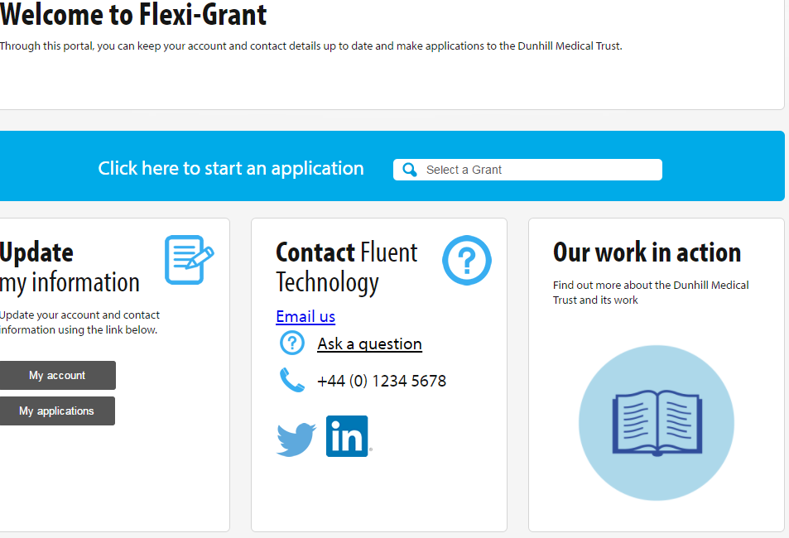
My assessments
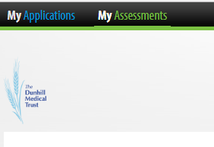
Under ‘My Assessments’, you will see the application(s) that you have agreed to review:
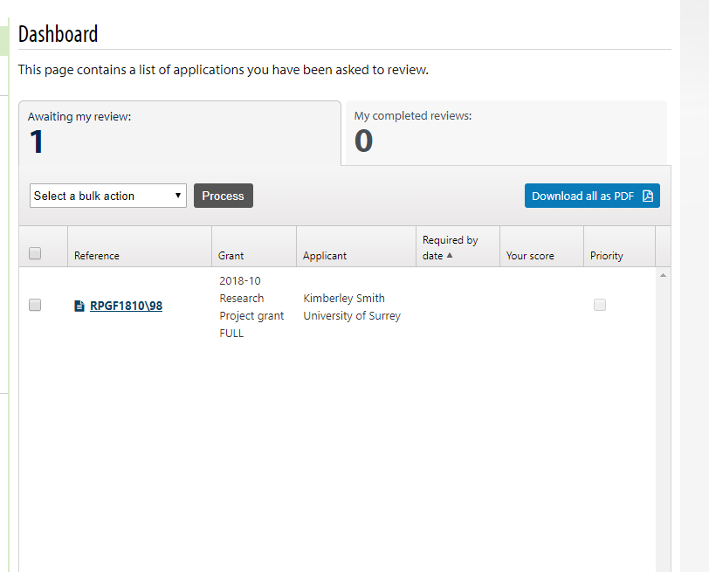

Downloading the application to work offline
You will need to confirm that you have accepted the review and do not have a conflict of interest before completing the review. If you wish to work offline, you can download a copy of the application by selecting the below button:

If you have agreed to review multiple applications and you just wanted to download one, you can tick the corresponding box for the application on the left-hand side and then from the dropdown menu, select Download as PDF and then press ‘Process’:
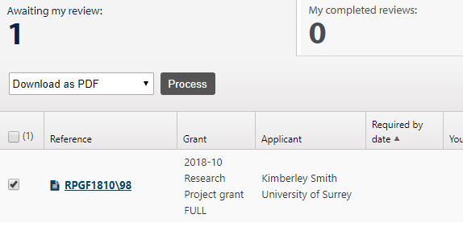
After selecting ‘Process’, this pop-up box will appear and you should select the third option:
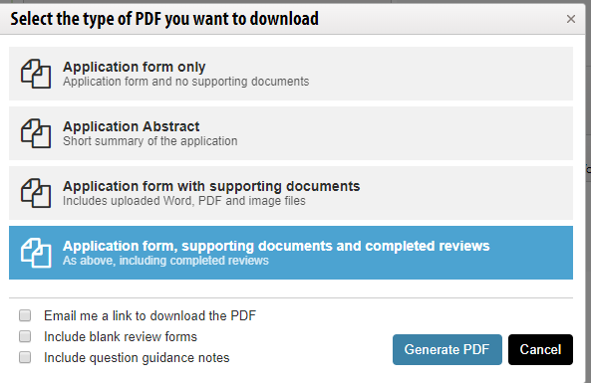
Downloading applications can take some time and therefore you also have the option of a link to the PDF being emailed to you once the download has finished.
Completing peer review
Please select the tick box next to the proposal and then from the dropdown list on the left, select ‘Record reviews’ as shown below and then press ‘Process’:
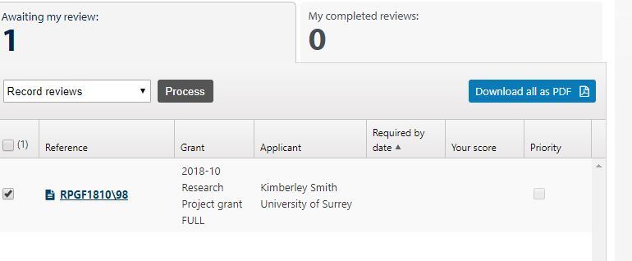

The review form, alongside the peer review scoring criteria, will then be displayed.

Each criterion requires a score and an optional comment. (You can see the scoring criteria at the end of this document). We ask for a summary comment at the end of the form to aid the Research Grants Committee in their discussion and there is also the option of providing feedback to the applicants.

At the end of each criterion and at the bottom of the form there are Save and Resubmit boxes
This button will allow you to save the form as you complete each criterion and to go back and revise any of your scores and comments up to the submission deadline.
While you are scoring, you can view the application by selecting the ‘Open application form’ button, which will open the application form in a new window. The Budgets tab will show the finance page and any uploaded documents can be found in the Related documents tab.

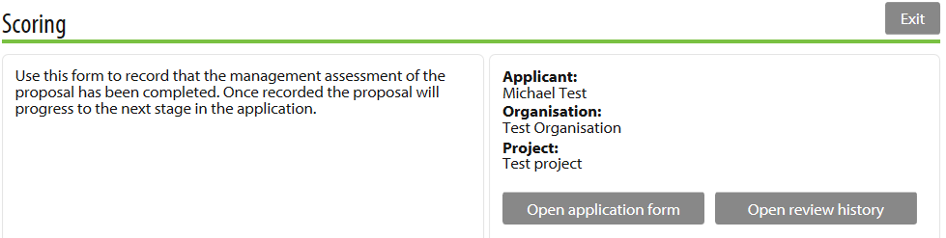
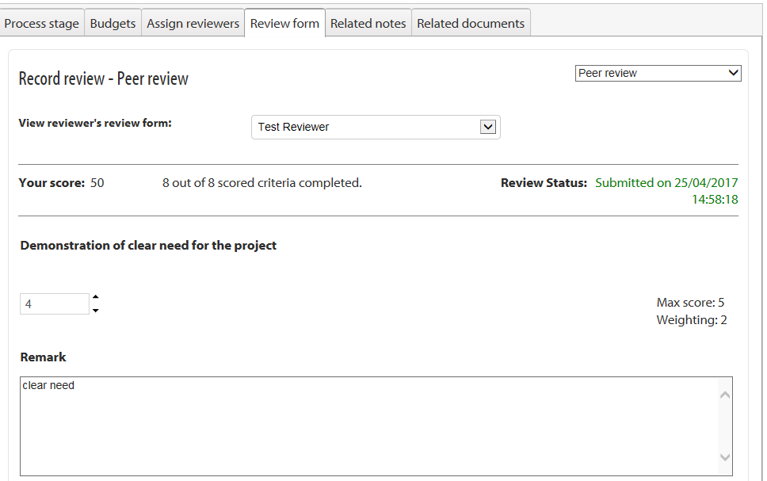
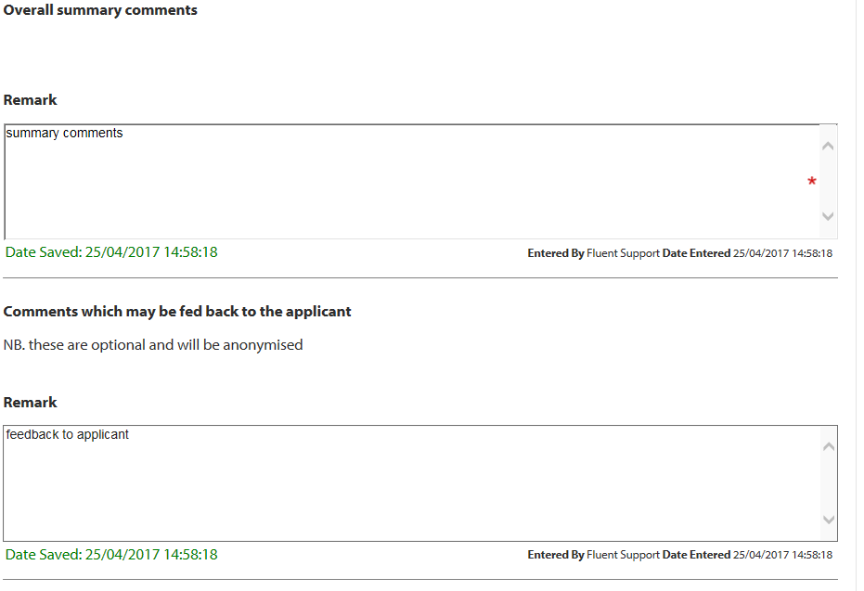

Peer Reviewers: Scoring rubric
 | 5 | 4 | 3 | 2 | 1
Demonstration of clear need for the project | Addressing a problem of high importance/interest/urgency. Clear and credible description with plans to support how it will make a difference to older people and a reasonable time frame in which it will do so, appropriate to the nature of the work. | Addressing a problem of high importance in the field. Clear and credible description of how it will make a difference to older people and a reasonable time frame in which it will do so, appropriate to the nature of the work but some weaknesses or lack of detail in the plan to do so bring down the overall impact to medium. | Application may be addressing a problem of moderate/high importance with a credible plan about how the project will have impact in the academic community, but weaknesses in the plan or proposal may not be of such relevance or urgency as to have a significant influence on policy or practice bring down the overall impact to low. | Application may be addressing a problem of moderate importance in practice with some consideration of how the project will have impact in the academic community, but significant weaknesses in the pathways to impact statement/plan bring down the overall impact to low. | Application has not sufficiently identified a clear need either within or beyond the academic community.
Novelty of the research proposal | The proposed work is highly original and significant and addresses important scientific questions or will enable them to be addressed through further development | The proposed work is original and significant and addresses important scientific questions or will enable them to be addressed through further development. | The proposed work has merit and meets satisfactory standards of originality and addresses reasonably important scientific questions or will enable them to be addressed through further development. | The work is of modest merit. It is unclear how novel the proposed work is and how likely it is to advance the field. | The proposed work is duplicative and is unlikely to advance the field.
Academic quality of the research proposal | The proposed work meets excellent standards in terms of quality and significance and addresses highly important scientific questions or will make a significant contribution to enabling them to be addressed. The proposed work is likely to be reproducible. | The proposal will add to understanding and is worthy of support, but is of lesser quality or urgency than more highly rated proposals. The proposed work is likely to be reproducible. | The proposal has significant potential academic merit but is not of a consistently high quality, although could result in some useful knowledge. The reproducibility of the work is questioned. | The proposed work is potentially of some merit but overall is of inconsistent quality or significance. | There are significant concerns about the quality of the proposed work.
Feasibility of the research plan | Clear, achievable and specific objectives, with a sound methodological approach. Has outlined risks and dependencies and provided a reasonable plan as to how these are to be addressed. | Clear, achievable and specific objectives, with a sound methodological approach. Appears to be some risks and dependencies with limited information on how these are to be addressed. | Sound methodological approach. Some concerns over how risks are to be addressed and/or some over-ambition regarding objectives. | While the plan seems sound in terms of methodological approach, its objectives seem over-ambitious in relation to proposed resources and timescale | The proposal is flawed in its scientific approach, or is repetitious of other work, or otherwise judged not worth pursuing; or which, though possibly having sound objectives, appears seriously defective in its methodology.
Competence of applicant/research team | Experienced Principal Investigator with a track record in the subject matter of the proposed project or a less experienced Principal Investigator (may be a first-time PI) but with a strong track record in the subject matter of the proposed project and tangible examples of support for the PI outlined. Roles of team members clear with a suitable range of skills and expertise (including appropriately experienced senior colleague as Co-I if first time PI). | Less experienced Principal Investigator (may be first-time PI) with a track record in the subject matter of the proposed project, but with few tangible examples of support for the PI outlined. Roles of team members clear with a suitable range of skills and expertise (including appropriately experienced senior colleague as Co-I if first time PI). | Suitably experienced Principal Investigator but team may lack some breadth or depth of experience appropriate to the project's subject matter. | Inexperienced Principal Investigator. Team roles unclear and/or lacking in breadth or depth of experience appropriate to the project's subject matter. | Principal Investigator/team wholly inadequate for the project's subject matter.
Suitability of research environment | Proposal demonstrates clearly that project team has access to facilities, equipment, samples and resources of the highest quality, appropriate to the project. | Proposal demonstrates clearly that project team has access to facilities, equipment, samples and resources, appropriate to the project. | Proposal demonstrates that project team has access to facilities, equipment, samples and resources, appropriate to the project. May need minor clarification in some areas. | Proposal lacks detail on project team's access to facilities, equipment, samples and resources, sufficient to introduce doubt as to whether the proposal could be delivered. | Team's access to facilities, equipment, samples and resources entirely inadequate.
Value-for-money | Project represents excellent value-for-money when considering proposed deliverables which include both impact and development of research capacity in relation to cost (which is realistic). | Project represents very good value-for-money when considering proposed deliverables - which include either impact or development of research capacity in relation to cost (which is realistic). | Project represents good value-for-money. Costs realistic but impact and/or development of research capacity may be more modest than the highest scoring. | Project's proposed objectives could be delivered at significantly lower cost than that proposed. | Project inadequately costed - e.g. the cost of some essential resources have not been included putting delivery of project in jeopardy.
Assessment of statement of benefit to other researchers in the field and/or in other disciplines within the UK and internationally | Addressing a problem of high importance/interest/urgency in the field, no real weakness detected. Clear and credible description with plans to support dissemination. | Addressing a problem of high importance in the field but some gaps in the dissemination plan bring down the overall impact to medium. | Application may be addressing a problem of moderate/high importance in the field with a credible plan about how the project will have impact in the academic community, but weaknesses in the plan bring down the overall impact to low. | Application may be addressing a problem of moderate importance in the field with some consideration of how the project will have impact in the academic community, but dissemination approach seems rather generic or non-specific bringing down the overall impact to low. | Application has significantly limited/flawed or no credible/feasible plan for impact within the academic community.

